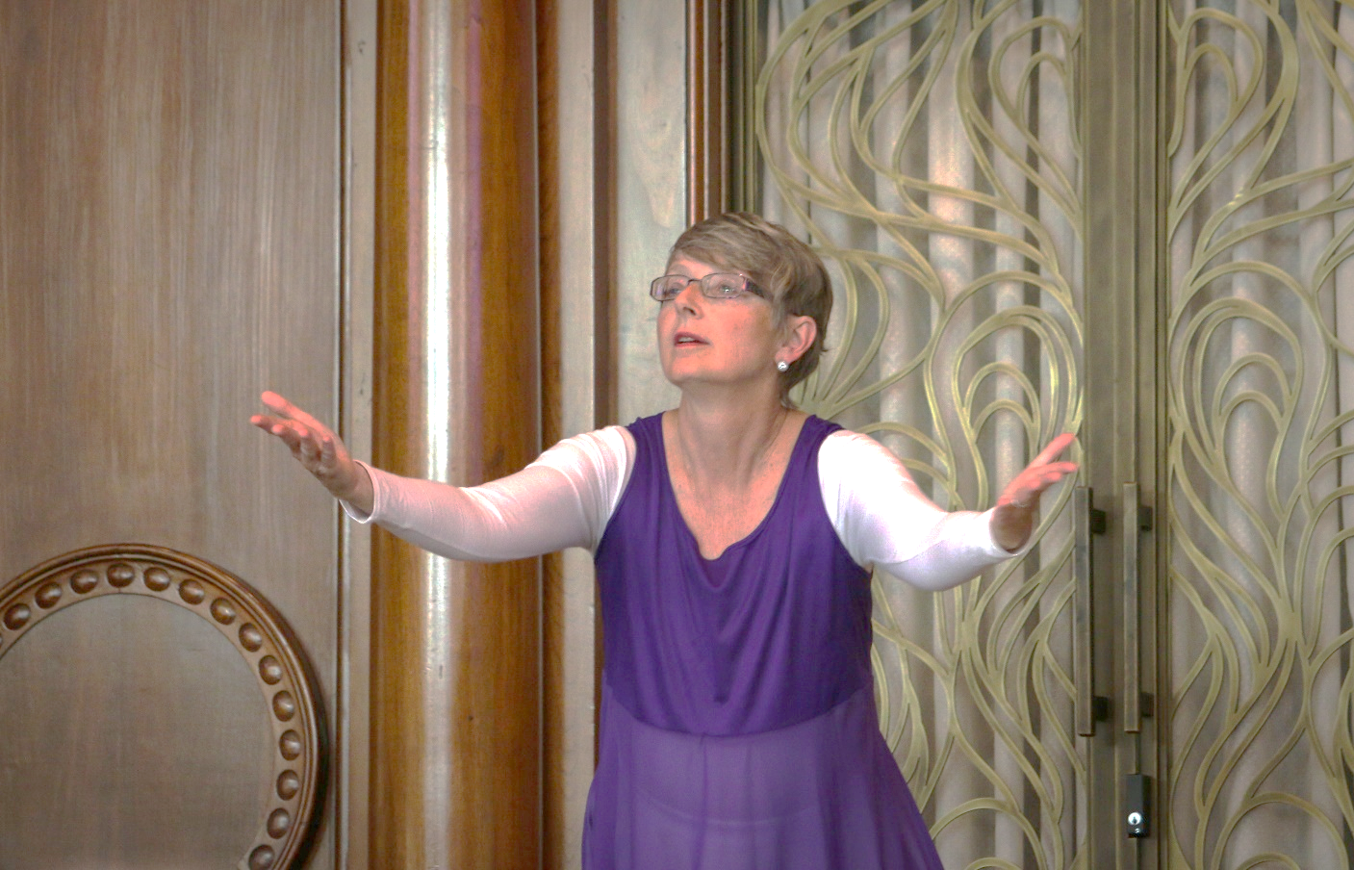
14TH ANNUAL
COMMONWEALTH INTERFAITH SERVICE:
PRAYERS FOR JUSTICE AND PEACE
May 23, 2022, 6:00 pm
Market Square Presbyterian Church
Harrisburg
A celebration of our religious diversity
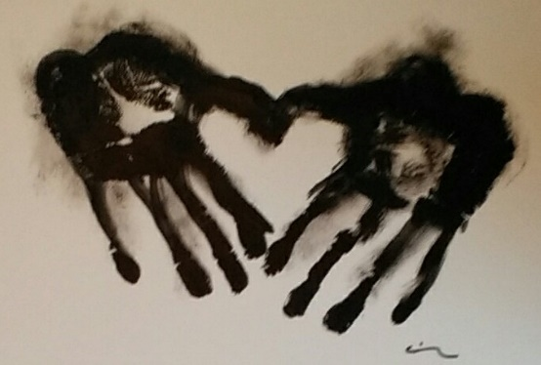

Logo by Rev. Virginia Parkum, Bright Dawn Center of Oneness Buddhism, Dragonfly Sangha
14TH ANNUAL COMMONWEALTH INTERFAITH SERVICE:
PRAYERS FOR JUSTICE AND PEACE
May 23, 2022

Gathering Music Mr. Tyler Canonico
Welcome from Market Square Presbyterian Church The Rev. Kim D. Wadlington
Welcome to this Service The Rev. Sandra L. Strauss
A Tribute to Our Friend Michael Sand The Rev. Sandra L. Strauss
The Most Rev. Michael J. Scalzi
Opening the Altar Shuso Rachael Kesler
Chalice Lighting The Rev. Joan M. Sabatino
Introduction The Most Rev. Michael J. Scalzi
& The Rev. Yvette Davis
Call to Prayer Dr. David Peisner, Jewish shofar call¹
The Rev. Dr. Larry D. Pickens, Christian call to worship
Mr. Labeeb Rehman, Islamic call to prayer²

One read by Mr. Ollie Silver
One: We come, unified in love, to lift our communal prayers for a common purpose. Our faith traditions call for us to live together in peace and love especially as we witness the mass movement of people due to factors beyond their control.
Many: We come together to lift our voices in prayer. Our prayers are a call for justice and peace for those who have had to make the choice to move to safety and for those who have been forced to move due to economic hardship, environmental disasters, war, and persecution. For we cannot truly have peace while there are refugees trying to escape danger and are looking for their place of safety.

Narrative The Most Rev. Michael J. Scalzi
Music Alleluia The Sanctuary Choir of Market Square
Ralph Manuel
Prayer Ms. Sukhman Kaur Grewal

One read by Ms. Jennifer Ross
One: We lament the hatred and the misunderstanding perpetrated against those who have had to flee their homes, their people, and their country.
Many: May we look beyond of the label of refugee, migrant, or displaced person and see the faces and hearts of those in need. May our hearts be open to their plight, to their need for safety, and their sadness, that can be overwhelming, as they leave behind the lives they know including their community, family, and friends.

Narrative The Rev. Yvette Davis
Music Ikh Shtey Unter a Bokserboym³/I Am Willing Ms. Susan Leviton
Zhame Telesin, music Chava Alberstein/Holly Near
Prayer Seetharamaswamy ji Srimat Tirumala Peddinti

One read by Mr. Zachariah Ahmad
One: We lament the fear that causes some to react with violence due to misunderstanding.
Many: We must be mindful that becoming a refugee is not a choosing. One becomes a refugee as one leaves one’s home and possibly one’s country to escape danger, persecution, and bloody conflict. May our prayers encircle the refugee with strength and courage.

Narrative The Most Rev. Michael J. Scalzi
Prayer The Rev. Dr. Lori Hatch-Rivera

One read by Ms. Uzma Ahmad
One: We lament the violence that has been poured down upon those who are in the midst of movement and escape. For the refugee is more than just the “stranger” mentioned in our holy writings.
Many: The refugee, the forced migrant, the displaced human is a person. A person with a history, a person created by God. A person who is making hard choices and doing the best for family and self. A person in need of our prayers for their safety.

Narrative The Rev. Yvette Davis
Dance (video) What the World Needs Now Is Love Ms. Becky Boone
Jackie De Shannon/ Written by Hal David & Burt Bacharach
Prayer Ms. Karen Hurst

One read by The Rev. Anthony Alexander
One: We lament the actions that lead to death for those who become refugees.
Many: We are mindful that more than half the refugees in the world are women and children. We recall that more than 25% of the refugees have not only lost their home, but also their country. Their forced migration has taken them to new countries with new and strange languages, homes, and living conditions. Let us hold the refugee in our prayers.

Prayer Ms. Carol Zandieh
Prayer Father James Lease

One read by Ms. Deborah Olson
One: We come together in our hope for justice for those who are displaced. We are mindful of those who offer a hand of hope and those who step into the chaos to provide support and positive attitudes reflecting God’s love.
Many: May our prayers and actions be a ray of hope in the world. We are thankful for those who have answered the call and provided homes and a future for those displaced. We are thankful for those who are providing funds to help transfer a refugee out of danger to a place of security and for those who are actively on-site offering openness, solidarity, charity, and protection for those in need.

Music Journey The Market Square Ringers
Kyle Webber
Closing Narrative The Most Rev. Michael J. Scalzi
& The Rev. Yvette Davis
Benediction Ms. Jennifer Ross (Jewish tradition)
The Rev. Dr. Amy D. Welin (Christian tradition)
Mr. Omar Alatar (Muslim tradition)
Closing Words/Invitation The Rev. Sandra L. Strauss
Closing Music Mr. Tyler Canonico

A free will offering will be taken with proceeds to benefit the International Service Center.

Participants
Ms. Uzma Ahmad, Ahmadiyya Muslim Community
Mr. Zachariah Ahmad, Ahmadiyya Muslim Community
Mr. Omar Alatar, Islamic Center of Pennsylvania?
The Rev. Anthony Alexander, St. Stephen’s Cathedral, Harrisburg
The Rev. Yvette Davis, Director, Popel Shaw Center for Race & Ethnicity
Ms. Beth Hager, Market Square Presbyterian Church, Photographer
The Rev. Dr. Lori Hatch-Rivera, Metropolitan Community Church of the Spirit
Ms. Karen A. Hurst, The Church of Jesus Christ of Latter-day Saints
Shuso Rachael Kesler, Dragonfly Sangha, Harrisburg
Father James Lease, Roman Catholic Diocese of Harrisburg
Ms. Susan Leviton, Susan Leviton Arts
The Market Square Ringers, Market Square Presbyterian Church, Harrisburg, Mr. Tyler Canonico, Director
Ms. Deborah Olson, Market Square Presbyterian Church, Harrisburg
Seetharamaswamy ji Srimat Tirumala Peddinti, Hindu American Religious Institute
Dr. David Peisner, Beth El Temple, Harrisburg
The Rev. Dr. Larry D. Pickens, Pennsylvania Council of Churches
Mr. Labeeb Rehman, Ahmadiyya Muslim Community
Ms. Jennifer Ross, Jewish Federation of Greater Harrisburg
The Rev. Joan Sabatino, Unitarian Universalist Justice PA
The Sanctuary Choir of Market Square, Market Square Presbyterian Church, Harrisburg, Mr. Tyler Canonico, Director
The Most Rev. Michael J. Scalzi, The Old Catholic Church, Province of the United States
The Rev. Sandra Strauss, Pennsylvania Council of Churches
The Rev. Kimberley Wadlington, Market Square Presbyterian Church, Harrisburg
The Rev. Dr. Amy D. Welin, St. Stephen’s Cathedral, Harrisburg
Ms. Carol Zandieh, The Baha'i Faith

¹A shofar is an instrument made from the horn of a ram or other kosher animal. It was used in ancient Israel to announce the New Moon (Rosh Chodesh) and call people together. It is also blown on Rosh Hashanah, marking the beginning of the Jewish New Year.
²Adhan/Islamic Call to Prayer:
Allahu Akbar, Allahu Akbar (2x) Allah is the Greatest, Allah is the Greatest (2x)
Ash-hadu allaa ilaaha ill-Allah (2x) I bear witness that there is none worthy of worship except Allah (God) (2x)
Ash-hadu anna Muhammad-arr-rasool- ullah (2x) I bear witness that Muhammad is the messenger of Allah (2x)
Hayy al-as-Salaah (2x) Come to Prayer (2x)
Hayy al-al-Falaah (2x) Come to Prosperity (2x)
Allahu Akbar, Allahu Akbar Allah is the Greatest, Allah is the Greatest
Laa ilaah illa-Llah There is none worthy of worship except Allah
The following phrases are added in the call to prayer for the pre-dawn (Fajr) Prayer after “Hayy al-al Falaah”
As-salaau khairum-minan-nawm (2x) Prayer is better than sleep (2x)
³Ikh Shtey Unter a Bokserboym
I stand beneath a carob tree. I got there, but not easily.
I sit beneath a fig tree, and all around, it’s green and free.
I lie beneath an almond tree.
It appeared in a dream to me.
A carob, a fig, and almond tree – I stop my tears, but not easily…

With many, many thanks to Market Square’s Nancy Sheets and Newman Stare, without whom this service would not work this evening!

